HOST APPLICATION
In the boxes with brackets, please put only one X for your choice
Company |  |  | Address
Theme
Level of difficulty |  |  | Name of speakers
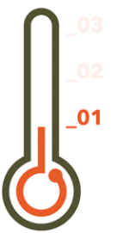  ()_01 | 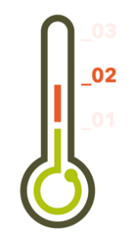  ()_02 |   ()_03
Target group (ex. Management, HR, entrepreneurs) |  |  | Language
 |  |  | English () / Danish ()
Number of physical seats |  |  | Time of the day
() Morning 08.30 – 10.30
() Afternoon 15.00-17.00
() Other
Date, Month or Quarter
Other
Contact person
Name |  |  | Title
E-mail |  |  | Phone number
() Agree with terms and conditions

